A000-ASIA-Indus Valley-Figurine-Mehrgarh-Terracotta-3000 BCE

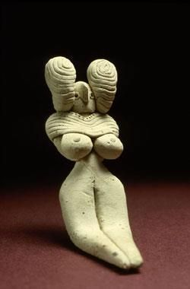

Fig. 1. Indus Valley-Figurine-Mehrgarh-Terracotta-3000 BCE

**Case no.: 3**

**Accession Number: A….**

**Formal Label:** Indus valley-Figurine-Mehrgarh-Terracotta-3000 BCE

**Display Description:**

This female figurine from Mehrgarh [Pakistan], c 3000 BCE, (Musée Guimet, Paris) is among the oldest in the Indus Valley and was prevalent even before pottery appeared. The more accurate terminology is “female figurine” because "mother goddess", implies that they had a cultic significance.

**LC Classification:** PK119

**Date or Time Horizon:** 3000-2500 BCE

**Geographical Area:** Mehrgarh

**Map, GPS coordinates: 29.38716 67.60955; 29º23'13.77" N 67º36'34.37" E**



**Cultural Affiliation:** Indus

**Medium:** terracotta

**Dimensions:**

**Weight:**

**Condition: original**

**Provenance:** Old European Collection

**Discussion:**

**References:**